“CONTEMPORARY TOPICS IN ORTHOPEDICS”

An Educational Conference Co-sponsored by
Maine Medical Education Trust and
Maine Ortho Conferences along with Covenant Health and Northern Light Health

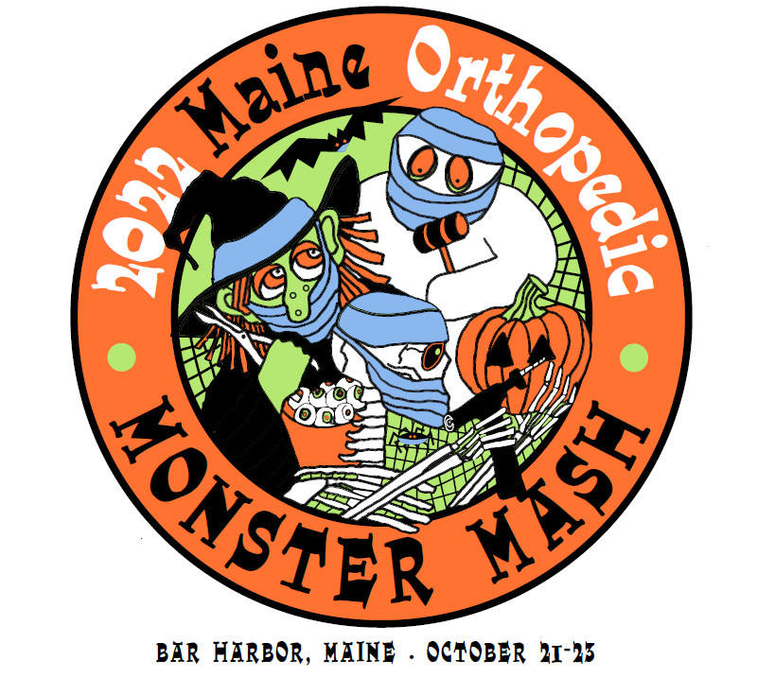

www.orthoconference.org

The Harborside Hotel
Bar Harbor Maine

October 21 - 23, 2022

31st Annual Meeting

Program Director: Garrett R. Martin, M.D.
Conference Coordinators: Laurie King and Pam Cyr

FACULTY

Dr W. Paul Bassett Northern Light Health
Bangor, ME

Dr Ian Dickey University of Colorado
Denver, CO

Dr Robert Gause Northern Light Health
Bangor, ME

Michael Genetti, CLU, ChFC Baystate Financial
East Providence, RI

Dr Poonam Khadka St Joseph Endocrinology/Diabetes Center
Bangor, ME

Daniel Morin Maine Medical Association
Manchester, ME

Dr Michael Morwood Atlantic Orthopaedics & Sports
Portsmouth, NH

Dr Ashley Mychak Northern Light Health Inland
Waterville, ME

Dr Jorge Orbay Miami Hand Institute
Miami, FL

Dr Michael Paci Northern Light Health
Bangor, ME

Dr Charles Pattavina Maine Medical Association
Manchester, ME

Kelly Roseberry, PT, DPT Travis Mills Foundation
Readfield, ME

Dr Nirav Shah Maine Center for Disease Control and Prevention
Augusta, ME

Dr Sarah Shubert Northern Light Mercy
Portland, ME

Dr Daniel Shubert Maine General Orthopaedics
Augusta, ME

Gordon Smith, Esq State of Maine
Augusta, ME

Dr Cameron Trubey DownEast Orthopedic Associates
Bangor, ME

Dr Tony Tsismenakis DownEast Orthopedic Associates
Bangor, ME

Dr David Urquia Virginia Commonwealth University
Richmond, VA

Dr Hans Van Lancker St Elizabeth’s Medical Center
Boston, MA

Karen Zupko Karen Zupko & Associates Inc
Chicago, IL

CONTEMPORARY TOPICS IN ORTHOPEDICS

FRIDAY, OCTOBER 21, 2022

Moderator: Dr David Urquia

MORNING SESSION 7:00-11:30 A.M.

7:00-8:00 A.M. Registration/Continental Breakfast – Harborside Hotel

7:45-8:00 A.M. Announcements by Garrett Martin, MD

8:00-9:00 A.M. Why I Switched to Robotic Assisted Joint Replacement - Dr Michael Morwood

9:00-10:00 A.M. Pursuing the Trapezium CRC Arthroplasty – Dr Jorge Orbay

10:00-10:30 A.M. Advocacy and Communications – Dan Morin (Maine Medical Association)

10:30-11:30 A.M. Advances in 3D Printing and Osseous Integration for Veterans – Dr Ian Dickey

Moderator: Dr David Urquia

AFTERNOON SESSION 2:00 – 6:00 P.M.

2:00-3:00 P.M. Partnership for Expert Care – Dan Morin

3:00-3:30 P.M. Interdisciplinary Approach to Limb Salvage vs Major Amputation –

Dr Ashley Mychak

3:30 – 4:15 P.M. Understanding Your Fiscal Health Risk Factors – Michael Genetti, CLU, ChFC

4:15– 5:00 P.M. Enhanced Recovery After Surgery – Dr David Urquia

5:00-6:00 P.M. The Current Status of Maine’s Opioid Epidemic – Gordon Smith, Esq

6:30-7:30 P.M. BANQUET SOCIAL HOUR – THE HARBORSIDE HOTEL

7:30-11:00 P.M. BANQUET – THE HARBORSIDE HOTEL

Guest Speakers: Dr Habib Dagher P.E. University of Maine Advanced Structures & Composites Center executive director

Dr Michelle Toder NL HEALTH Cross County Bike Adventure

Halloween Party Theme – Costumes encouraged, but not required

CONTEMPORARY TOPICS IN ORTHOPEDICS
SATURDAY, OCTOBER 22, 2022

Moderator: Dr Sarah Shubert/Dr Daniel Shubert

MORNING SESSION 6:30 A.M.-12:00 P.M.

6:30-7:00 A.M. Registration/Continental Breakfast/Announcements – Harborside Hotel

6:45-7:00 A.M. Announcements by Garrett Martin, MD

7:00-8:00 A.M. Early Sports Specialization – Dr Cameron Trubey

8:00-8:30 A.M. Quadriceps Tendon Autograft ACL Reconstruction – Dr Daniel Shubert

8:30-9:15 A.M. COVID: Past, Present, and Future – Dr Nirav Shah

9:15-9:45 A.M. Orthopaedic Oncology – Sins to Avoid – Dr Ian Dickey

9:45 -10:30 A.M. Managing Distal Radius Fracture, Understanding Forearm Interosseous Ligament, Management of Difficult Elbow Instability – Dr Jorge Orbay

10:30-11:15 A.M. Current Treatment of Large/Massive Rotator Cuff Tears –Arthroscopy VS RSA –
Dr Sarah Shubert

11:15-12:00 P.M. Cervical Myelopathy - Dr Michael Paci

Moderator: Jessica Lucas, MD

AFTERNOON SESSION 1:00-6:30 P.M.

1:00-2:00 P.M. What Every Orthopedic Surgeon Needs to Know About Their Business Office
(How to Avoid Clawbacks and the OIG; Reports: What You Need and How to Use Them to Diagnose Problems; Patient Financial Counseling is a Must) - Karen Zupko

2:00-3:00 P.M. The Protocolization of Orthopaedic Fracture Care: From an Art to a Science -
Dr Hans Van Lancker

3:00-4:00 P.M. Using Data to Improve Opioid Prescribing – Dr Charles Pattavina

4:00-5:00 P.M. The 31st Maine Infantry Regiment in Virginia-Penobscot County Soldier Story – Dr David Urquia

5:00-6:30 P.M. Challenging Cases in Adult Reconstruction -Orthopedic Panel Discussion –

Dr Tony Tsismenakis and peers

6:30-8:00 P.M. EXHIBITOR RECEPTION AT HARBORSIDE HOTEL

CONTEMPORARY TOPICS IN ORTHOPEDICS
SUNDAY, OCTOBER 22, 2022

Moderator: W Paul Bassett, MD

MORNING SESSION 6:30-11:30 A.M.

6:30-7:00 A.M. Registration/Continental Breakfast/Announcements– Harborside Hotel

6:45-7:00 A.M. Announcements by Garrett Martin, M.D.

7:00-7:45 A.M. The History of Pediatric Orthopedics in Maine – Dr Robert Gause

7:45-8:30 A.M. Management of Adolescent Idiopathic Scoliosis - Dr W. Paul Bassett

8:30-9:15 A.M. Practice Transitions – Karen Zupko

9:15-10:00 A.M. Osteoporosis Treatment - Dr Poonam Khadka

10:30-11:15 A.M. Travis Mills Foundation: Real World Rehab - Kelly Roseberry, PT, DPT

11:30 A.M. ADJORNMENT FOLLOWING CLOSING REMARKS

(SPEAKERS AND TIMES ARE SUBJECT TO CHANGE)

-NOTES-

This activity has been planned and implemented in accordance with the accreditation requirements and policies of the Accreditation Council for Continuing Medical Education (ACCME) through the joint providership of the Maine Medical Education Trust and Maine Ortho Conferences.
The Maine Education Trust is accredited by the Maine Medical Association Committee on Continuing Medication Education and Accreditation to provide continuing medical education for physicians.
The Maine Medical Education Trust designates this live activity for a maximum of 20 AMA PRA Category 1 Credits. Physicians should only claim credit commensurate with the extent of their participation in the activity.
This activity qualifies for [2] credit(s) of the 3 CME credit requirement for opioid medication education found in P.L. 2015, Chapter 488, Maine’s legislation to address the opioid drug crisis.

CONTEMPORARY TOPICS IN ORTHOPEDICS
31st ANNUAL MEETING
BAR HARBOR MAINE

Dates for Next Year
To be determined

Visit our web site: www.orthoconference.org

Program Director: Garrett R. Martin, M.D. (207) 307-8902

